Instructions: You will need to fill in the table below with the information that you have collected through your research. Be specific with the type of market failure you are referring to and detailed with your explanation of it. The table will expand to accommodate the information you include. Record all sources used in the space below the table.

Source of market failure | Detailed Example (including diagram(s) where appropriate) | Government measures or suggested measures and explanation
- Positive externalities | Externalities are when third parties are affected by other people's economic decisions. Positive consumption externalities create benefits which positively impact a third party, and cause market quantity to be more than optimal quantity, and also cause market price to be more than optimal price, creating inefficiency. Externalities cause market failure because the price mechanism does not account for the social costs and benefits of production and consumption.  Graph of a positive consumption externality:  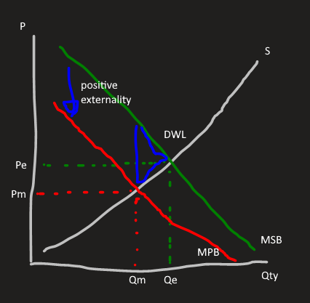  Qm and Pm is at market equilibrium, Qe and Pe is at the "correct" or efficient equilibrium. MSB is marginal social benefit, MPB is marginal private benefit.  An example of a positive externality is education. It is a positive consumption externality since it benefits third parties, such as employers who can find employees more easily if more of the population is educated, and consumption related since it refers to the consumption of education as a service. In addition, education also provides a benefit to consumers since it improves their later lives, further showing education is a positive externality.  Education is a source of market failure because the social benefit is greater than the private (personal) benefit, and the benefit provided to third parties is undervalued from the individual perspective. | Positive externalities (ones relating to consumption) are a problem and cause market failure because they are under consumed. In order to remove the deadweight loss and help return the market to an equilibrium, governments can provide subsidies, or create rules and regulations.  In the case of the education industry, the Australian government currently subsidises the education industry. This helps remove the deadweight loss because it effectively shifts the supply curve downward, which reduces prices and encourages consumption, which fixes the problem of under consumption. A subsidy is shown in the graph below:  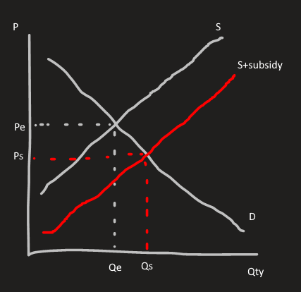  Qe and Pe is at market equilibrium, Qs and Ps are after the subsidy has been granted.  Subsidies are very efficient at reducing market failure relating to education, since they increase consumption and thus overcome the market failure. However, subsidies are a costly investment for governments, so often this is reflected in government taxation, with a proportion of taxation going towards the education sector.  Overall, subsidies reduce market failure by increasing consumption of education, and this increasing economic efficiency since the market is reverted to equilibrium. The subsidy also removes the deadweight loss in the market caused by the market failure, which reverts equity.
- Negative externalities | Externalities are when third parties are affected by other people's economic decisions. Negative consumption externalities negatively impact the third party, and cause market quantity to be less than the optimal quantity, and also cause market price to be less than optimal price, creating inefficiency. Externalities cause market failure because the price mechanism does not account for the social costs and benefits of production and consumption. In addition, externalities also cause a deadweight loss.  Graph of a negative consumption externality:  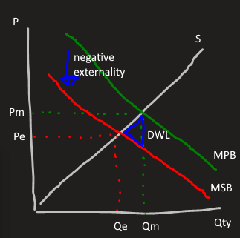  Qm and Pm is at market equilibrium, Qe and Pe is at the "correct" or efficient equilibrium. MSB is marginal social benefit, MPB is marginal private benefit.  An example of a negative externality is smoking in public, caused by the smoking industry. This is a negative consumption externality because it relates to the (over) consumption of cigarettes. Smoking in public negatively impacts other people's day due to the pollution caused by smoking, hence how it impacts a third party and is a negative externality. If the cigarettes weren't over-consumed, smoking would not be as big of a problem and hence why smoking is aimed to be reduced in this situation.  Smoking is a source of market failure because the social benefit is less than the private benefit, and thus a deadweight loss is created. | Negative externalities (ones relating to consumption) are a problem and cause market failure because they are overconsumed, so governments want to decrease the consumption of the product. This can be done through adverts or taxes.  In the case of the smoking industry, the Australian government places taxes on cigarettes such that with every sale, the producer must pay a tax to the government. This causes producers to raise their prices to cope with the tax, and thus quantity demanded decreases, shown in the diagram below.  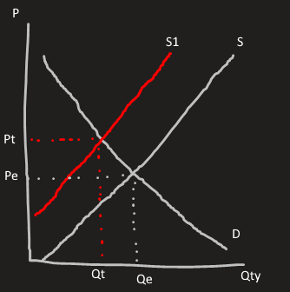  Qe and Pe is at market equilibrium, Qt and Pt are after the tax has been implemented.  Taxes are somewhat efficient at reducing the effect of smoking as a negative externality, however cigarettes are a relatively inelastic good (due to smoking addictions), so it's not as efficient as taxing other goods. Nevertheless, a 2011 study showed that a 10% increase in price of cigarettes generally results in a 4% reduction in consumption.  Overall, taxes reduce market failure caused by smoking by decreasing the consumption of cigarettes, and so increases economic efficiency. The deadweight loss is also removed by the tax, which increases economical equity, as a DWL is a reduction in equity.
- Market power | A lack of market power is a lack of competition between producers within a market which causes market inefficiency (due to a decrease in total surplus) and thus a deadweight loss. Uncompetitive (imperfect) markets result in lower levels of economical welfare, and redistribute surplus in favour of producers.  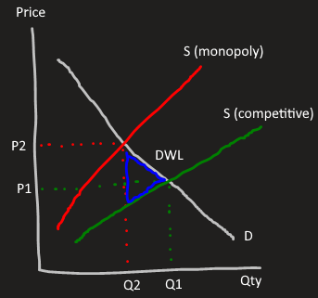  An example of abuse of market power are the supermarkets in Australia, mainly Coles and Woolworths. Coles and Woolworths are the two main supermarkets in Australia and so share a lot of market power, and while this is not a monopoly it is still an oligopoly since they both hold a lot of market power. | The Competition and Consumer Act of 2010, administered by the Australian Consumption and Consumer Commission (ACCC) allows the government to intervene with monopolies or firms which abuse market power, as the Act provides consumer protection against monopolies by disallowing blatant anti-competitive behaviour that strengthens the monopoly's market power. This Act can allow governments to force firms to change their prices.  Relating to the example of Coles and Woolworths, the Australian government does not take very much action to reduce the market power held by these firms, however instead they've put measures in place to make sure they cannot gain even more market power, or abuse their market power. One such measure is the Competition and Consumer Act of 2010 mentioned above. While this does not reduce the market power Coles and Woolworths have, it prevents them from abusing the power, eg. Predatory pricing, resale price maintenance.  These restricted conditions placed on monopolistic supermarkets decrease market failure by preventing abuse of market power, and so increases economic efficiency. In addition, the restriction placed on pricing of supermarket goods increases equity, since without the ACCC, supermarkets would be able to price their goods as high/low as they wanted, which would unfairly impact consumers. However, this solution does not remove the deadweight loss caused by monopolistic markets, which negatively impacts equity.

Sources:
Pettinger, T., 2020. Negative Externalities - Economics Help. [online] Economics Help. Available at: <https://www.economicshelp.org/micro-economic-essays/marketfailure/negative-externality/> [Accessed 30 April 2020].
Pettinger, T., 2020. Abuse Of Monopoly Power - Economics Help. [online] Economics Help. Available at: <https://www.economicshelp.org/microessays/competition/abuse-monopoly-power/> [Accessed 30 April 2020].

Pettinger, T., 2020. Positive Externalities - Economics Help. [online] Economics Help. Available at: <https://www.economicshelp.org/micro-economic-essays/marketfailure/positive-externality/> [Accessed 1 May 2020].

ncbi. 2011. Effects of Tobacco Taxation and Pricing on Smoking Behaviour in High Risk Populations: A Knowledge Synthesis. [online] NCBI. Available at:
<https://www.ncbi.nlm.nih.gov/pmc/articles/PMC3228562/> [Accessed 30 April 2020].

tutor2u. 2020. Introduction To Market Failure | Economics | Tutor2u. [online] Available at: <https://www.tutor2u.net/economics/reference/introduction-to-market-failure> [Accessed 1 May 2020].

